Assessment Schedule – 2011
Physics: Demonstrate understanding of aspects of electricity and magnetism (90937)
Evidence Statement
Significant figures are not required and correct units are required only in the questions that specifically ask for them.
Q | Achievement | Merit | Excellence
ONE  (a) | Friction between the lunch wrap and the hand / charging is caused by rubbing of the lunch wrap.  OR  Electrons are transferred between Sally and the plastic wrap. | Friction/rubbing between the lunch wrap and hand causes electrons transfer between them. | Replacement for c(ii)  The hand and plastic wrap become oppositely charged as a result of electrons transferring from one to the other.
(b) | Mentions that no charge is created.  OR  Charge is created – describes charge transfer. | The total number of charges between the hand and the lunch wrap remains constant because charge is always conserved.  OR  Charges are never created, they are transferred from one surface to another. | Replacement for c(ii)  Electrons are transferred causing an excess of electrons and hence a negative charge on one surface. Or similar for a positive charge due to deficit of electrons.
(c)(i)  (ii) | • Shows negative charges on the lunch wrap.  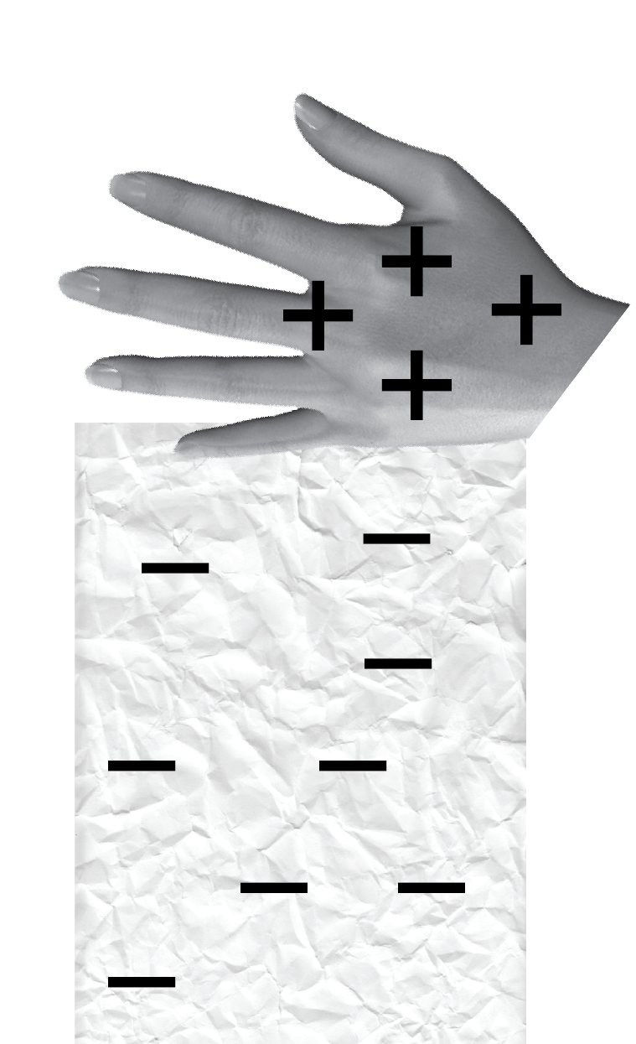  • Opposite charges attract, so they stick together.  • Foil is a metal and it is a conductor.  OR  Plastic is a poor conductor of electricity. | • Negative charges on the lunch wrap explained by electron transfer from hand to plastic.  • Plastic is an insulator/poor conductor of electricity and does not lose charge easily  • Rubbing causes charge separation, hand and wrap oppositely charged and opposite charges attract.  • Foil / aluminium is a conductor and remains neutral / discharges/ disperses (eg to earth) so no force of attraction / does not stick / falls off. | • Shows negative charges on the lunch wrap  • Plastic is a poor conductor of electricity and retains charge transferred to it.  • During rubbing, the plastic and the hand acquire opposite charges. The hand is positively charged, so the plastic is negatively charged. Opposite charges attract, so they stick together.  • There is no net charge transfer between the foil and the hand, because foil is a metal, and it is a good conductor of electric charges. OR Metal is a good conductor and any charge transferred / induced is quickly conducted away leaving the metal neutral. So no force of attraction / does not stick / falls off quickly

Scoring Rubric
N0 | N1 | N2 | A3 | A4 | M5 | M6 | E7 | E8
No correct relevant physics. | Identifies one physics principle relevant to the part of the question. | Identifies two physics principles relevant to the part of the question. | 3 Correct  answers from Achieve-ment section | 4 Correct  answers from Achieve-ment section. | 2 correct  answers from Merit section. | 3 correct  answers from Merit section. | 3 correct answers from (c). | All of (c) is correct.

Q | Achievement | Merit | Excellence
TWO  (a) | R_{T} = R₁ + R₂ + R₃ +…  = 8.0 × 12.5  R = 100 Ω
(b) | Mentions low voltage per bulb.  OR  Mentions bulbs are in series.  OR  Voltage is shared/ 7.5 V for each bulb  OR  Mentions lower power per bulb. | It is a series circuit, the voltage is shared and so the bulbs receive only a share of the voltage/ only receive 7.5V (implication that this is low for the bulbs).  OR  The bulbs are in series, this means the current is smaller due to the high resistance.  OR  Lower voltage (or current) results in lower power for each bulb.
(c) | Other bulbs will not light up.  OR  Current flow stops.  OR  Circuit stops due to incomplete circuit. | Other bulbs will not light up. It becomes an incomplete circuit and no current flows through it.  OR  Other bulbs will not light up. The bulbs are in series so if one bulb stops working no current flows through the whole circuit.
(d) | Total current through the circuit, I_{T} = V_{T} / R_{T}  = 60 / 100 = 0.60 A  OR  One correct step is given. | Total current through the circuit, I_{T} = V_{T} / R_{T}  = 60 / 100 = 0.60 A  Total power drawn from the battery, P = V_{T} × I_{T}  = 60 × 0.60 = 36.0 W  OR  Uses I = 60 / 12.5 = 4.8 A  to give E = 34560 J | Total current through the circuit, I_{T} = V_{T} / R_{T}  = 60 / 100 = 0.60 A  Total power drawn from the battery, P = V_{T} × I_{T}  = 60 × 0.60 = 36 W  Energy drawn from the battery,  E = P × T  = 36 × (2 × 60) = 4320 J

Scoring Rubric
N0 | N1 | N2 | A3 | A4 | M5 | M6 | E7 | E8
No correct relevant physics. | Identifies 1 correct equation or physics principle relevant to the part of the question. | Identifies 2 correct equations or physics principles relevant to the part of the question. | 2 Correct  answers from Achieve-ment section. | 3 Correct  answers from Achieve-ment section. | 2 Correct answers from Merit section | 3 Correct answers from Merit section | (d) steps 1 and 2 are correct but used time as 2 min to get an answer 72 J. | All of (d) is correct.

Q | Achievement | Merit | Excellence
THREE  (a) | (i) An arrow is drawn pointing upwards or parallel to the left edge, as shown.    OR  Correctly describes use of the Right Hand rule (or similar)  OR  Clockwise magnetic field lines drawn. | BOTH  - An arrow is drawn pointing upwards or parallel to the left edge, as shown.  AND  (ii) From the right hand rule (or similar), the direction of the magnetic field formed, due to the current, is in clockwise direction. (Clockwise direction may be shown on diagram)
(b) | 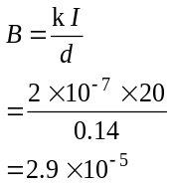 | 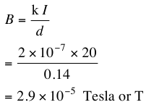
(c) | The strength of the magnetic field at P is zero.  OR  The fields from the two wires are the same / total is 5.8 x 10-5 T | The strength of the magnetic field at P is zero because the fields are equal in strength and they cancel.  OR  Fields are equal in strength because same current or distance. | • The strength of the magnetic field at P is zero.  • At point P, fields from both wires meet in the opposite direction.  • The fields are equal in strength, because they are caused by equal currents flowing at equal distance from P.
(d) | W is marked as shown.  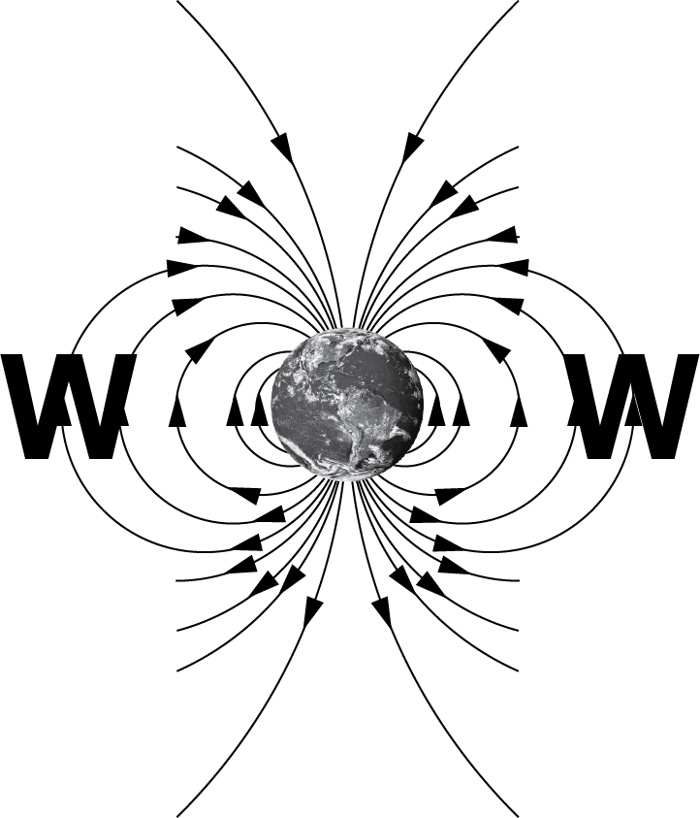  OR  More widely spaced lines means weaker field | W is marked as shown.  AND  The strength of the field is shown by the spacing between the lines; the spacing is the greatest at these points.

Scoring Rubric
N0 | N1 | N2 | A3 | A4 | M5 | M6 | E7 | E8
No correct relevant physics. | Identifies one physics principle relevant to the part of the question. | Identifies two physics principles relevant to the part of the question. | 2 Correct  answers from Achieve-ment section. | 3 Correct  answers from Achieve-ment section. | 2 correct  answers from Merit section. | 3 correct  answers from Merit section. | (c) correct but only mentions 1 of same distance / current. | All of (c) is correct.

Q | Achievement | Merit | Excellence
FOUR  (a)  S N | The coil becomes magnetised.  OR  The iron core/head is attracted / pulled to the coil.  OR  The iron head completes the circuit. | When the current flows, the coil becomes magnetised and pulls soft iron core to the left.  AND  EITHER The head of the core touches the two metal contacts OR thereby completing the light bulb circuit.
(b)(i) |  | Correct poles  AND
(ii) | EITHER the correct shape OR the correct direction is given. | 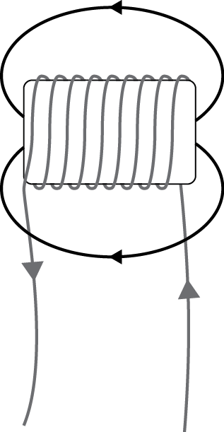  BOTH the correct shape and the correct direction are given.
(c) | ONE of:  • Increase the current through the coil.  • Increase the number of turns in the coil/ tighten turns/ move coils closer together  • Add an iron core | TWO of:  • Increase the current through the coil.  • Increase the number of turns in the coil/ tighten turns/ move coils closer together  • Add an iron core
(d) | ONE correct calculation is shown. | TWO correct steps with answers are shown. | Total power = 4 × 35 = 140 W  Total current, I = P × V = 140 / 65  = 2.15 A  Total resistance, R = V / I  = 65 / 2.15  = 30.2 Ω  = 30 Ω

Scoring Rubric
N0 | N1 | N2 | A3 | A4 | M5 | M6 | E7 | E8
No correct relevant physics. | Identifies one physics principle relevant to the part of the question. | Identifies two physics principles relevant to the part of the question. | 3 Correct  answers from Achieve-ment section. | 4 Correct  answers from Achieve-ment section. | 2 correct  answers from Merit section. | 3 correct  answers from Merit section. | correct process for (e) but premature rounding of I to give R = 32.5 Ω | All of (e) is correct.

Judgement Statement
 | Not Achieved | Achievement | Achievement  with Merit | Achievement  with Excellence
Score range | 0 – 10 | 11 – 19 | 20 – 26 | 27 – 32

